tcn
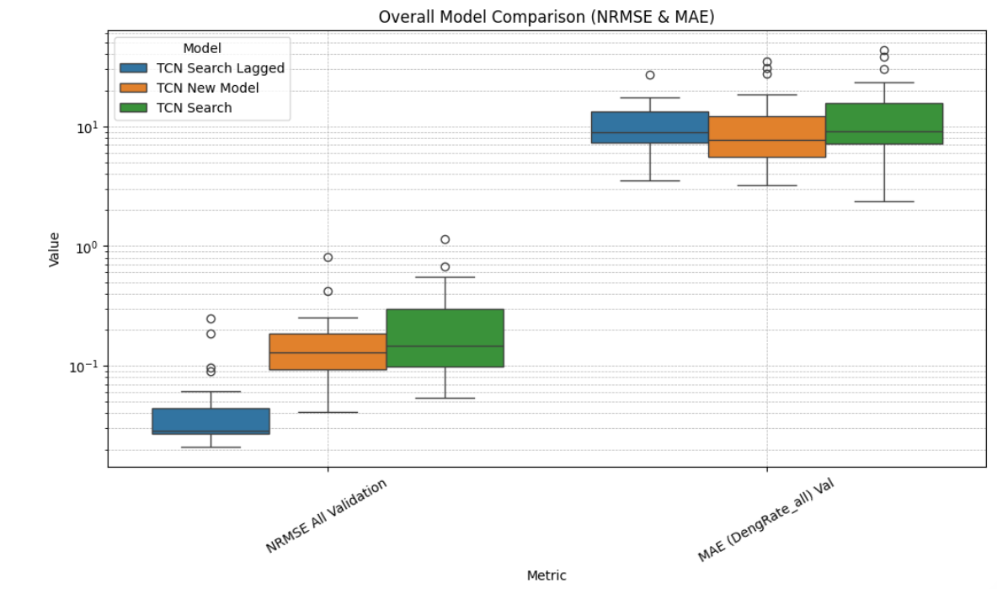
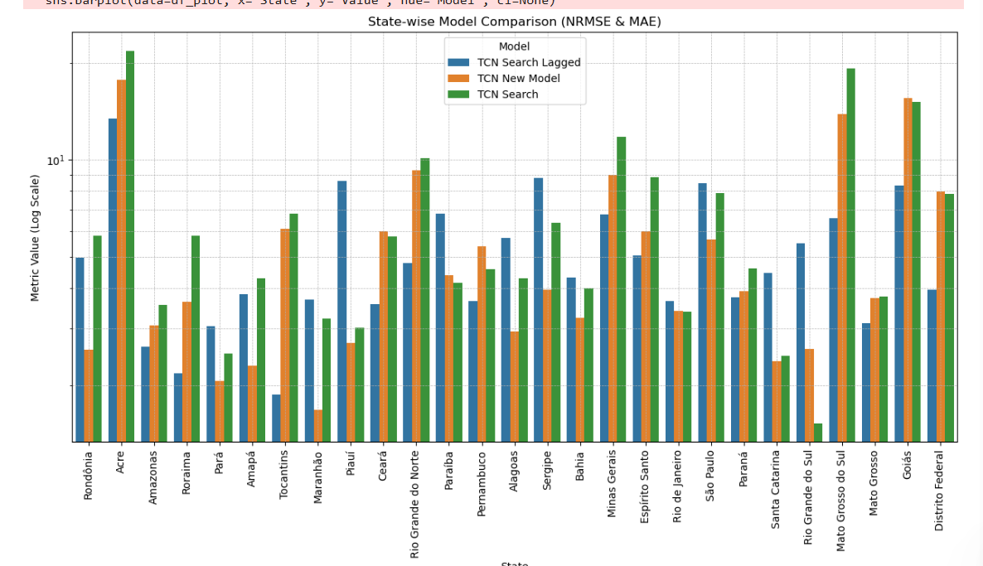
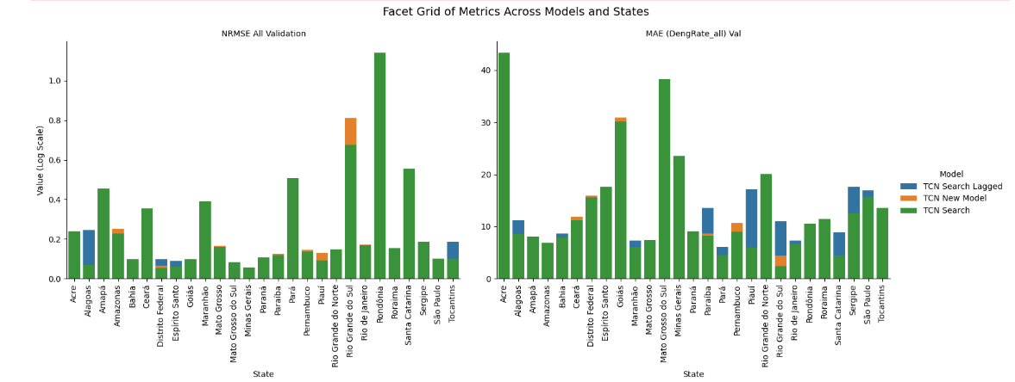
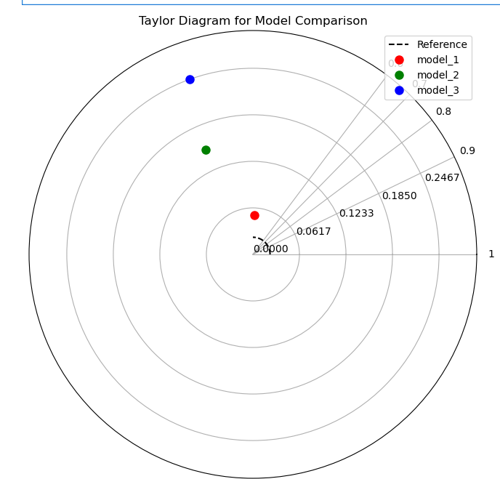

Lstm
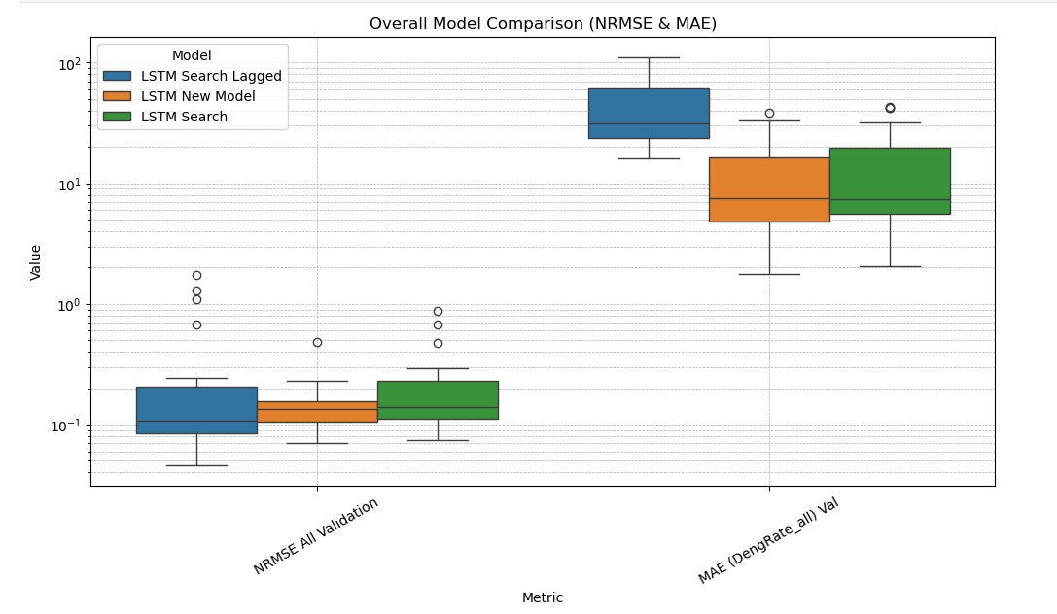
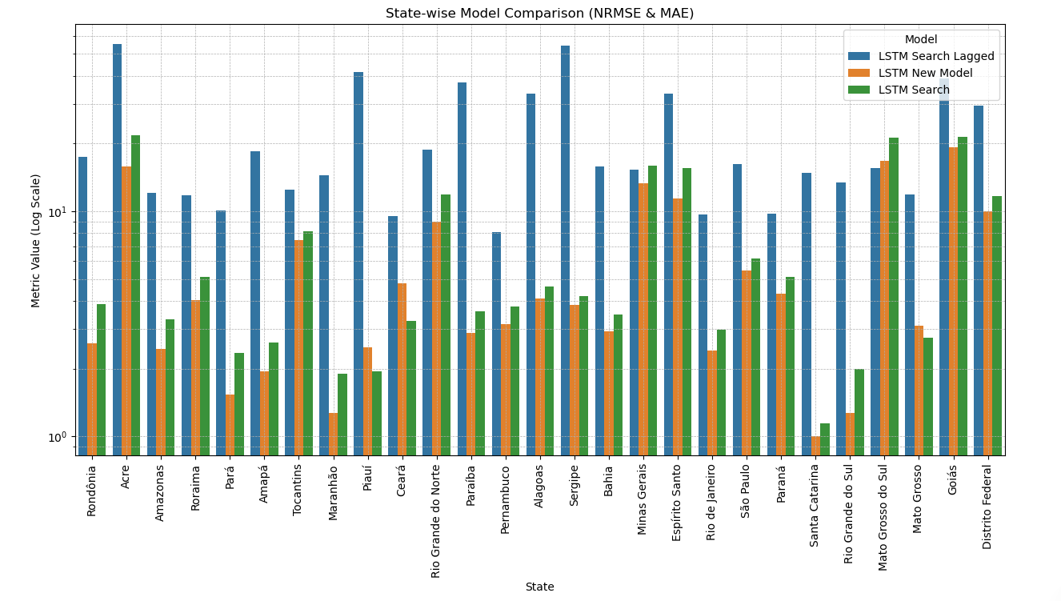
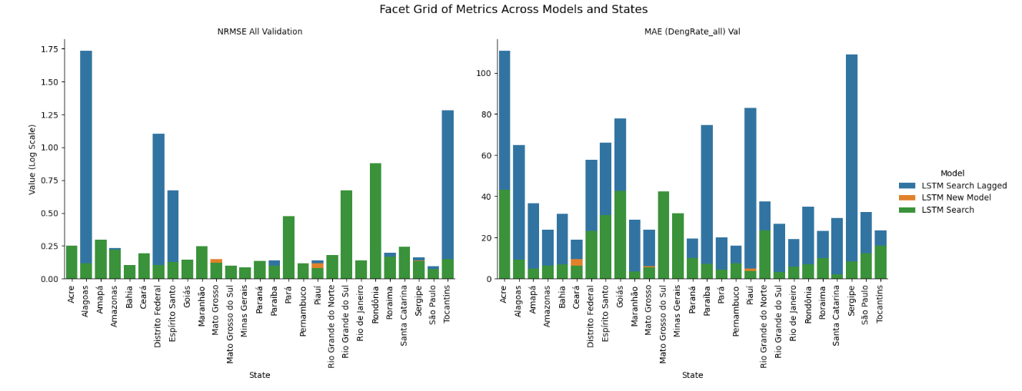
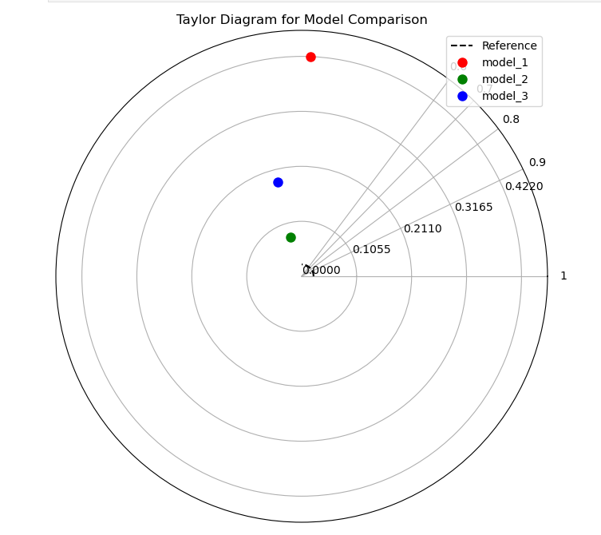
Tft
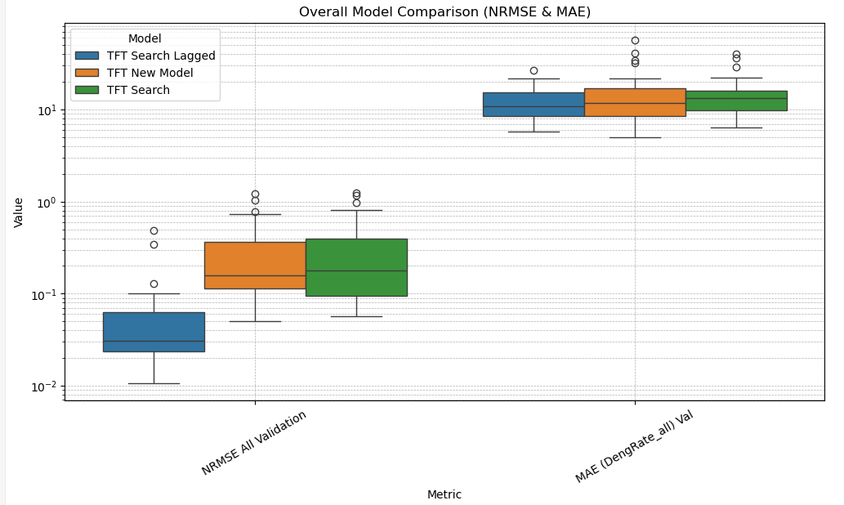
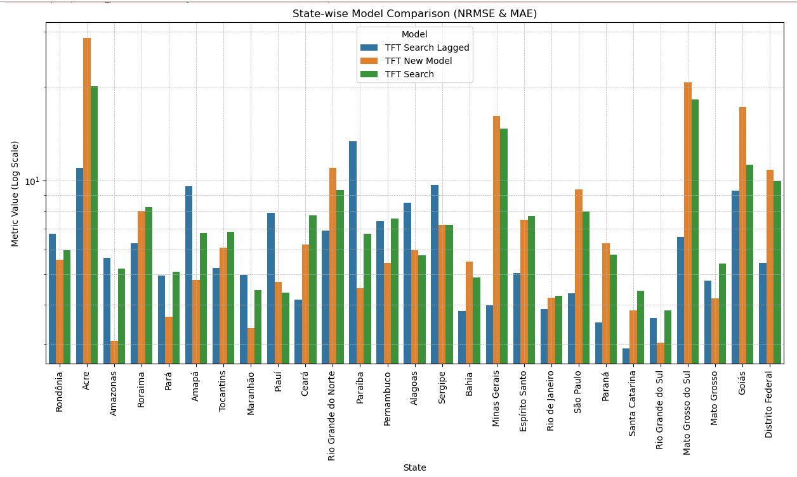
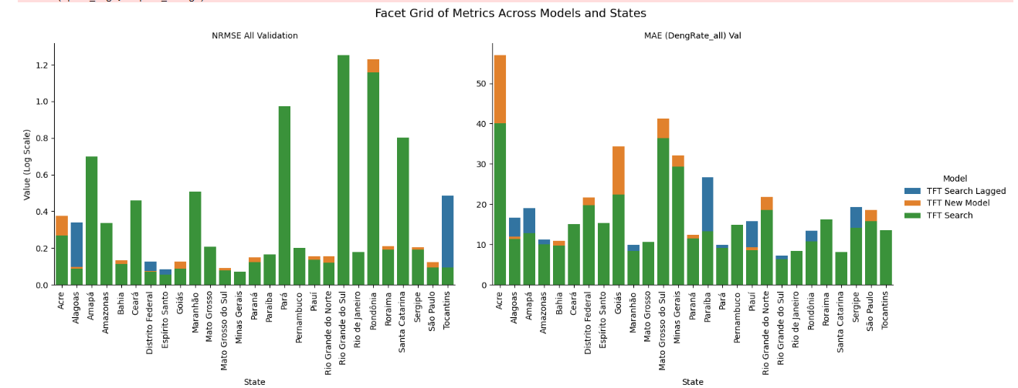
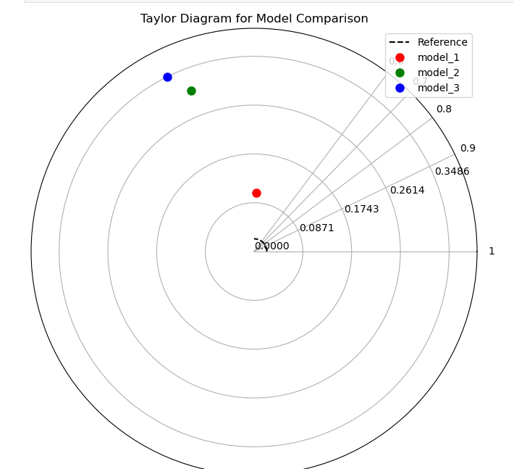
Catboost
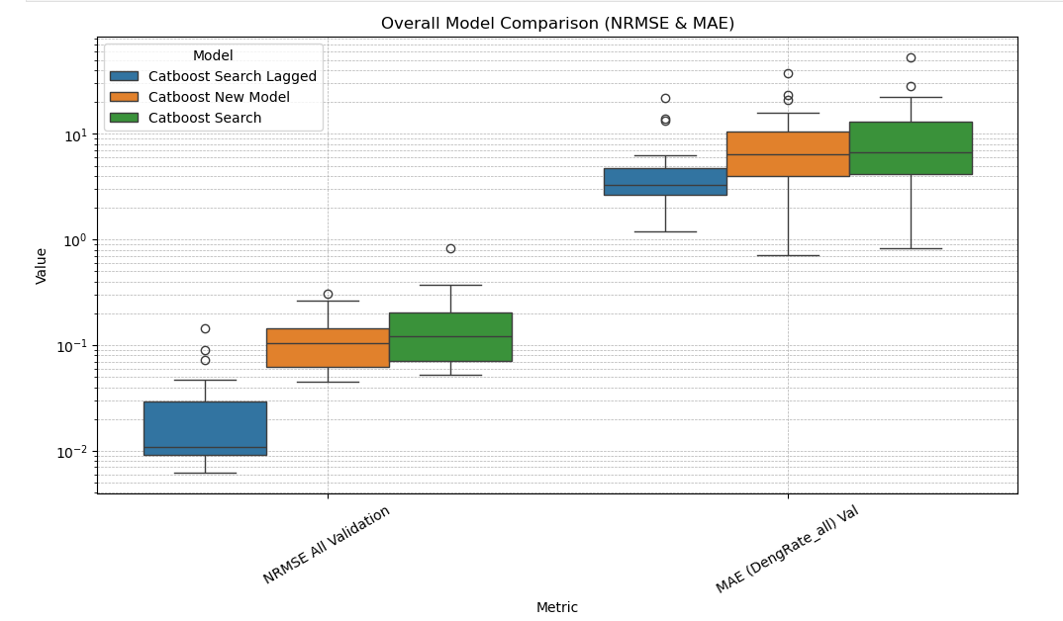
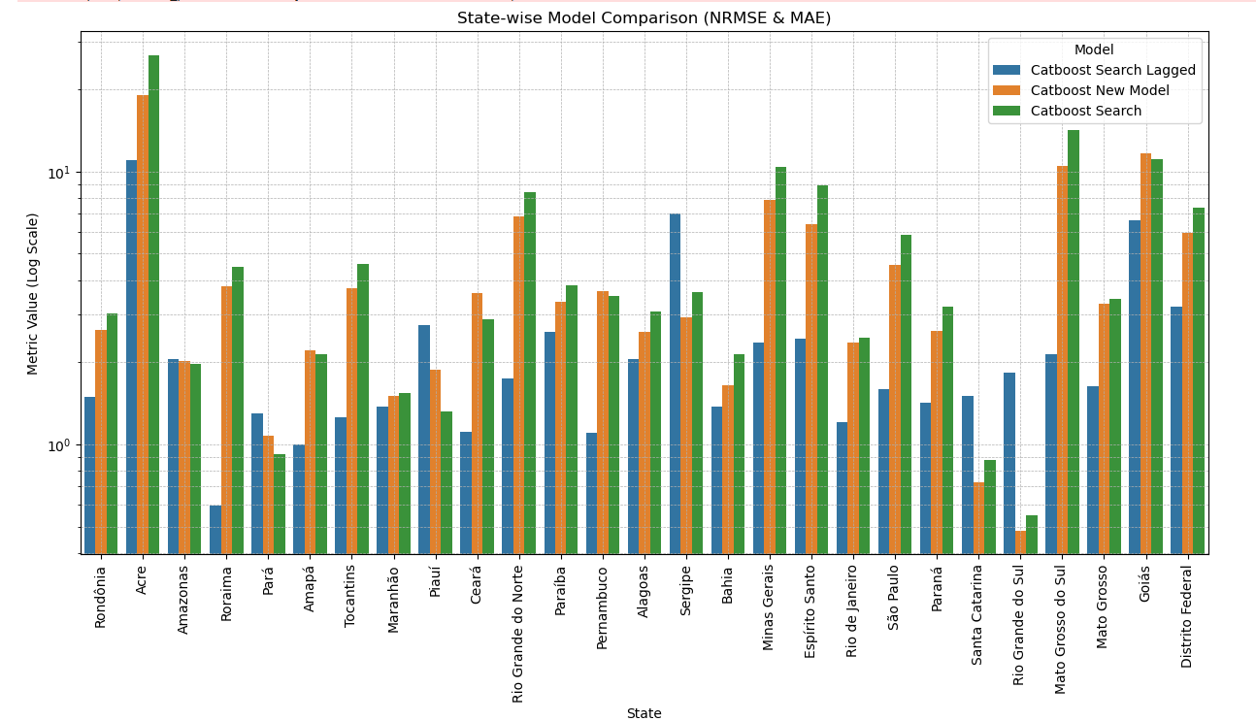
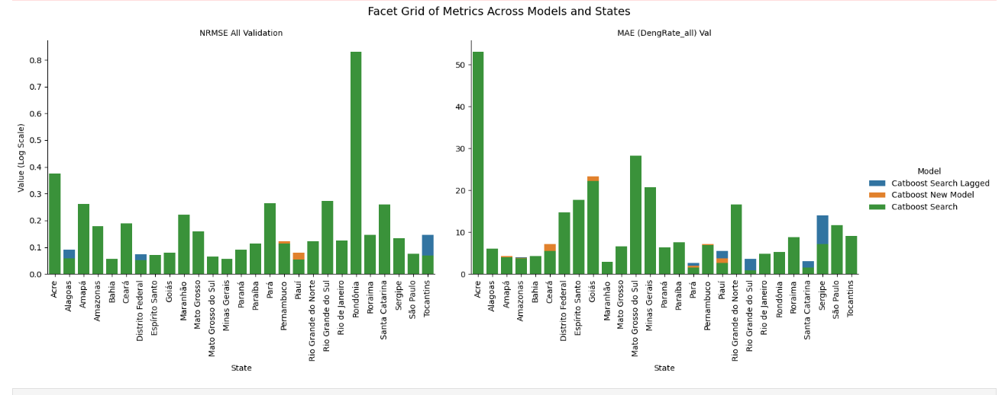
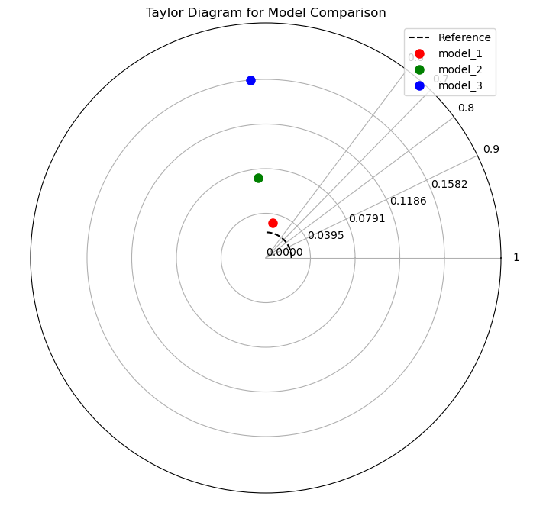
Ensemble:
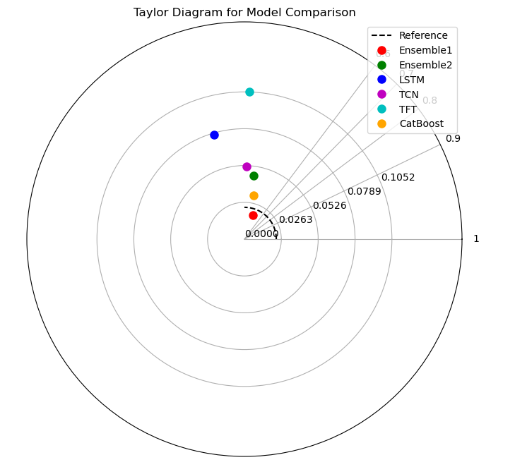
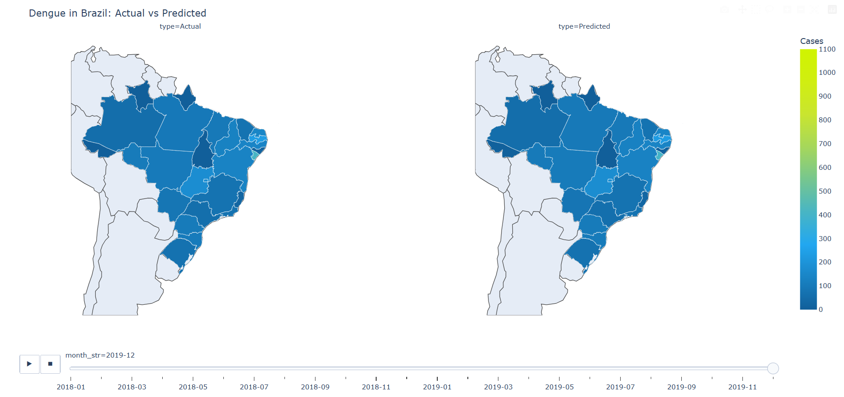
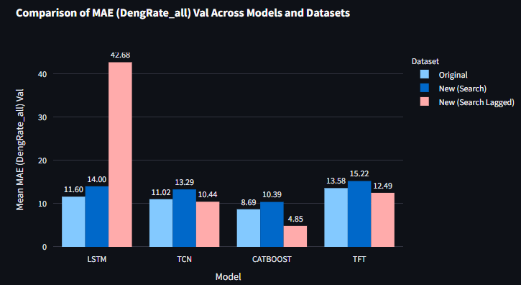
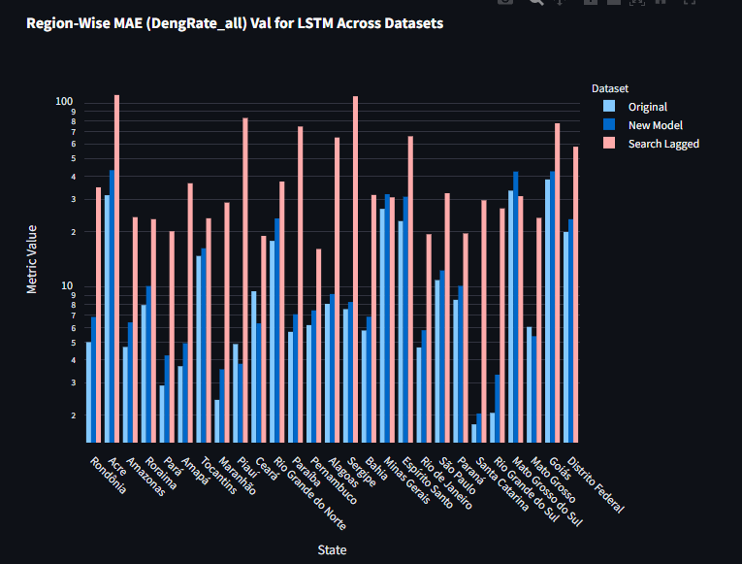
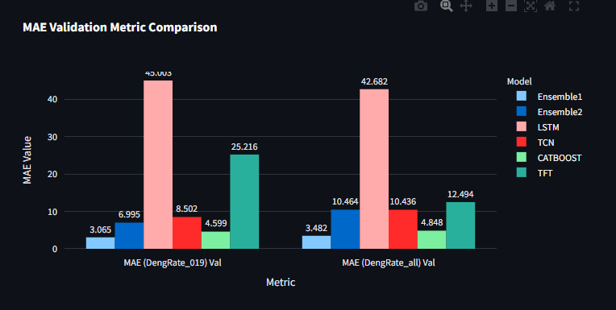
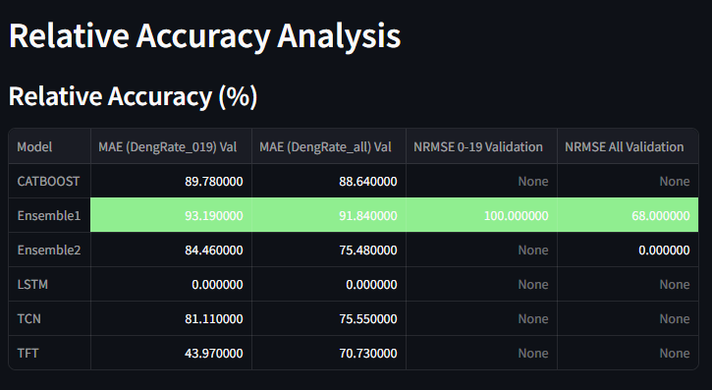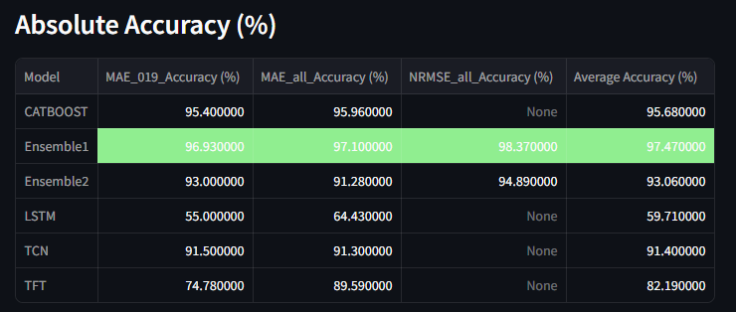
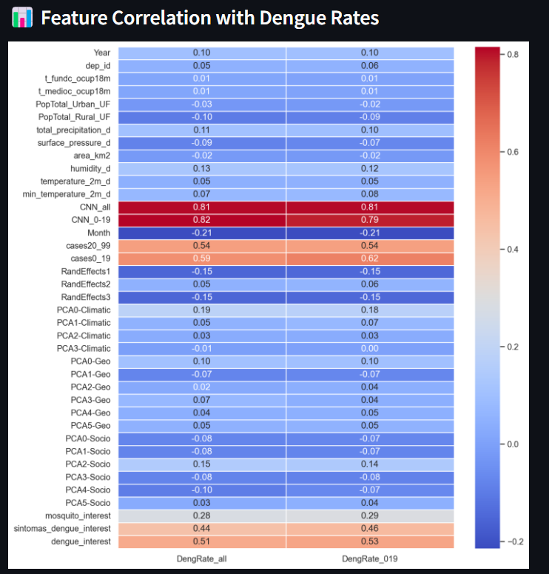
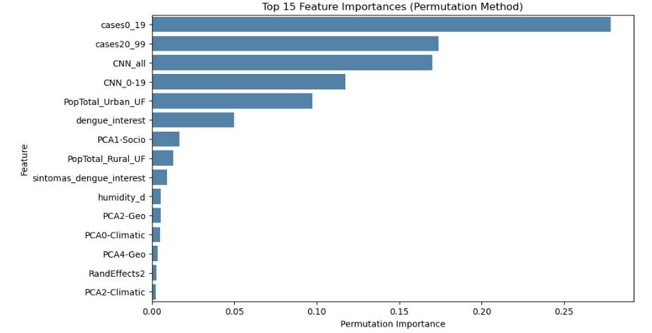
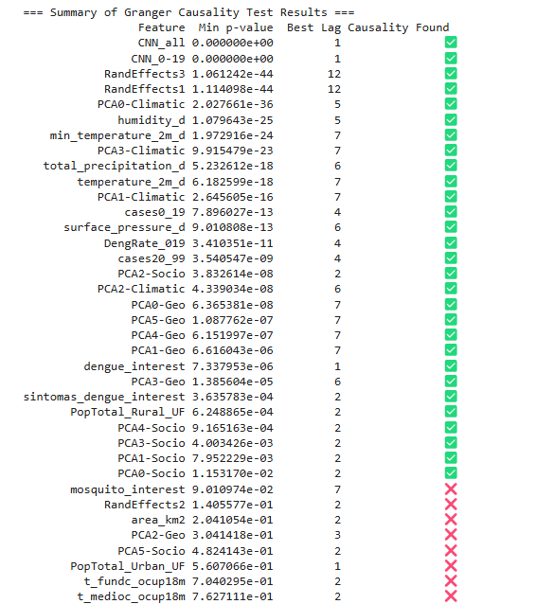
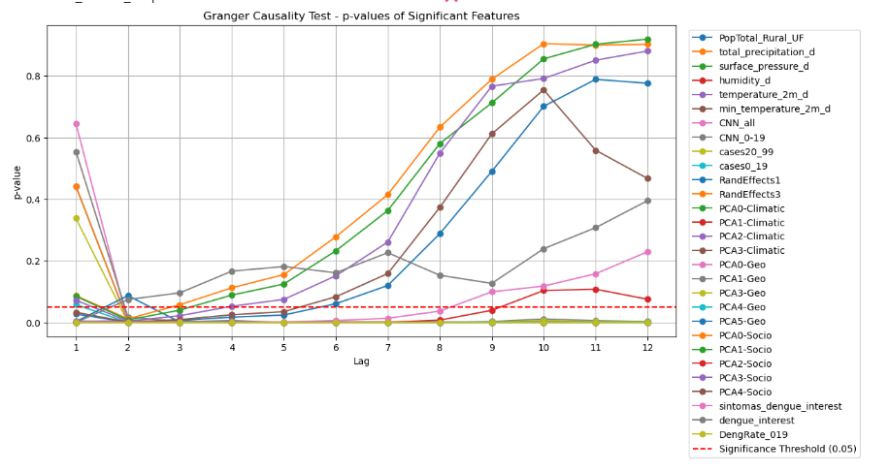
=== Cross-Correlation Summary ===
Feature Max Correlation Best Lag
DengRate_019 0.982228 0
CNN_0-19 0.928471 1
CNN_all 0.918401 1
cases0_19 0.586183 0
cases20_99 0.542118 0
dengue_interest 0.511393 0
sintomas_dengue_interest 0.441092 0
mosquito_interest 0.282021 0
humidity_d -0.236067 -5
PCA0-Climatic 0.231153 1
RandEffects3 0.219892 5
RandEffects1 0.219627 5
total_precipitation_d -0.182050 -5
PCA1-Climatic -0.174050 5
PCA3-Climatic 0.172109 -7
PCA2-Climatic 0.167168 -5
PCA2-Socio 0.149512 -2
PCA0-Geo 0.137455 -3
temperature_2m_d 0.135313 3
PCA5-Geo 0.130500 -3
min_temperature_2m_d 0.128899 2
PCA1-Geo -0.112280 -3
PCA3-Geo 0.106575 -9
PopTotal_Rural_UF -0.103656 -10
surface_pressure_d -0.097149 3
PCA4-Socio -0.095412 0
PCA4-Geo 0.082531 2
PCA3-Socio -0.081408 0
PCA1-Socio -0.077983 0
PCA0-Socio -0.077579 12
RandEffects2 0.052535 12
PopTotal_Urban_UF -0.034679 -12
PCA2-Geo 0.031933 -10
PCA5-Socio 0.028377 9
area_km2 -0.020392 0
t_fundc_ocup18m 0.015881 -12
t_medioc_ocup18m 0.015214 -12

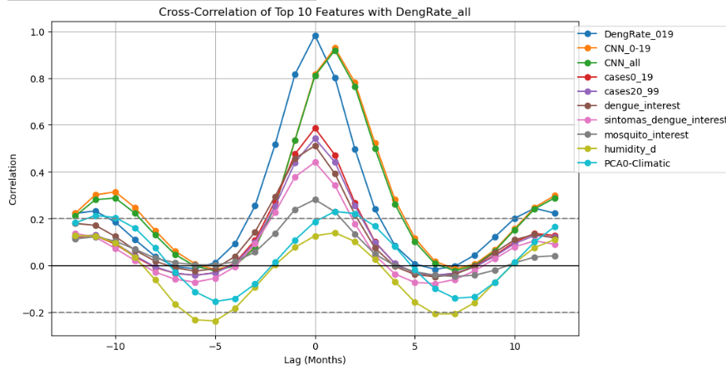
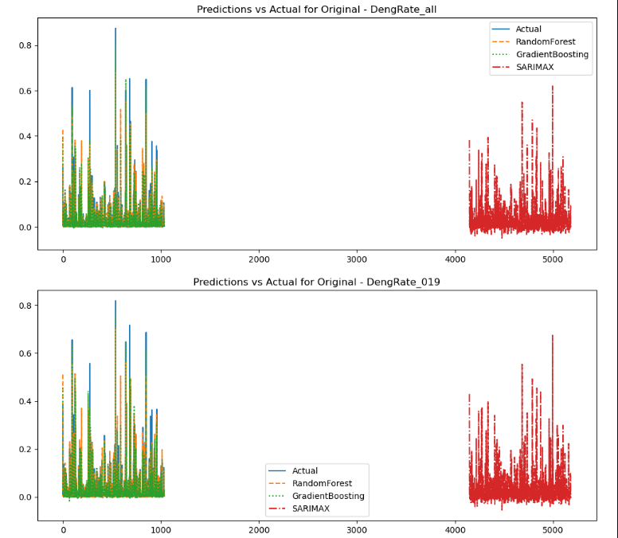
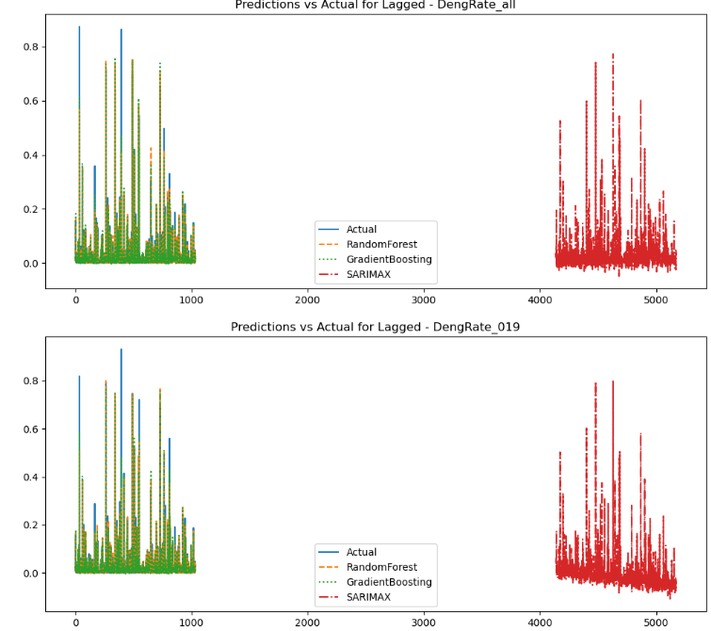
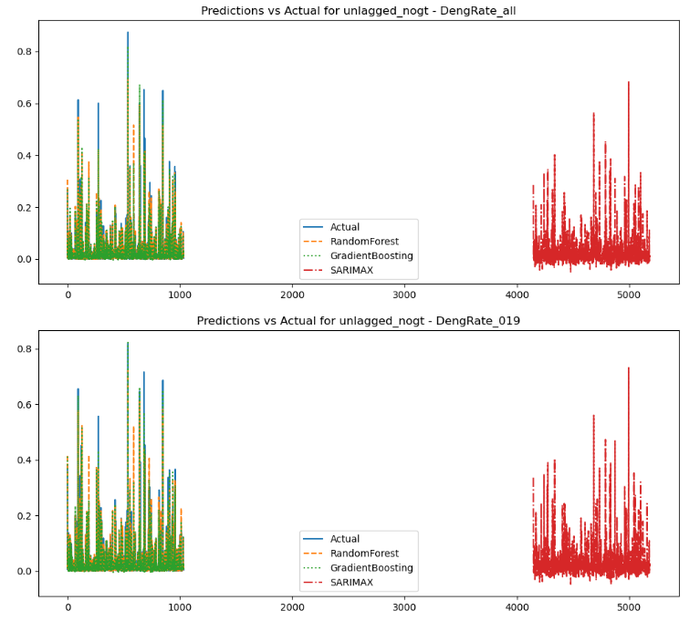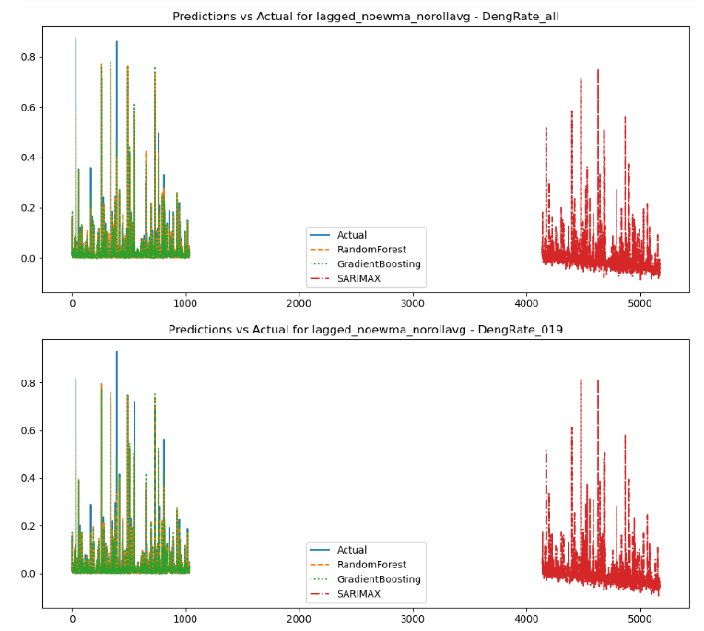
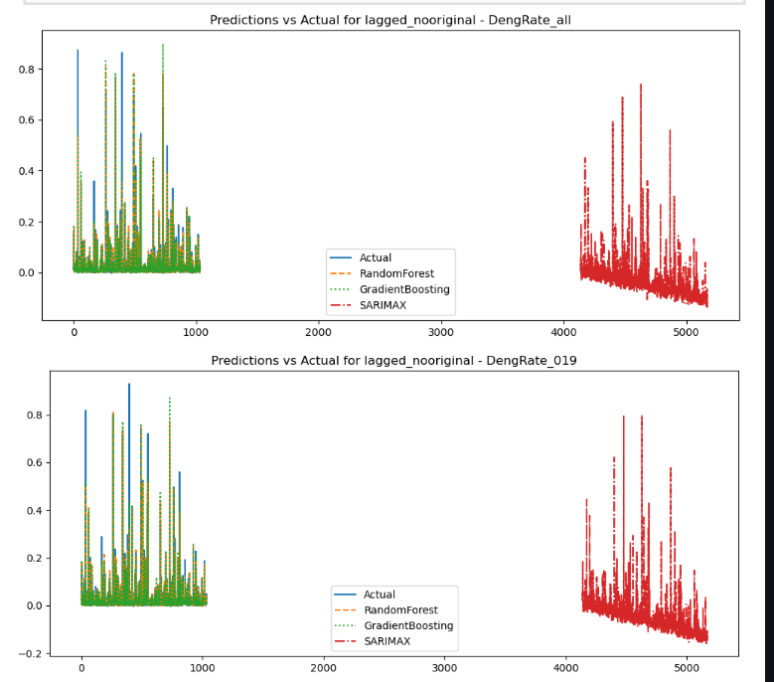
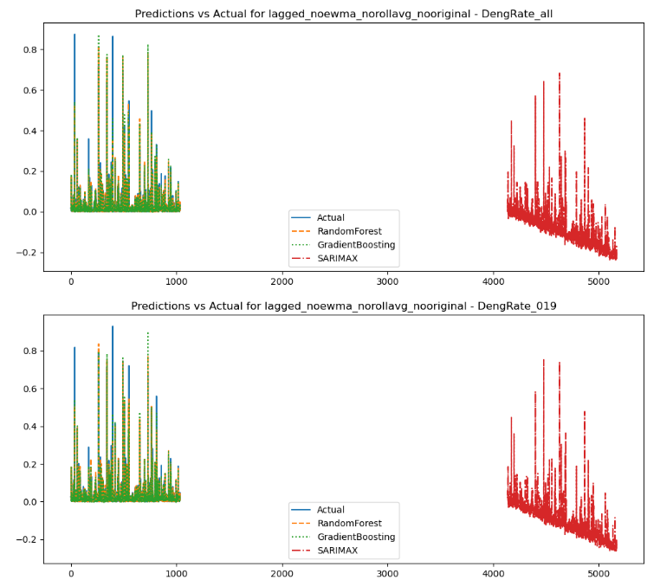
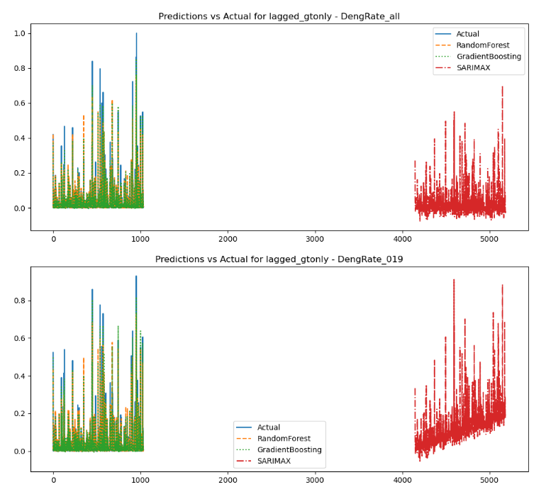
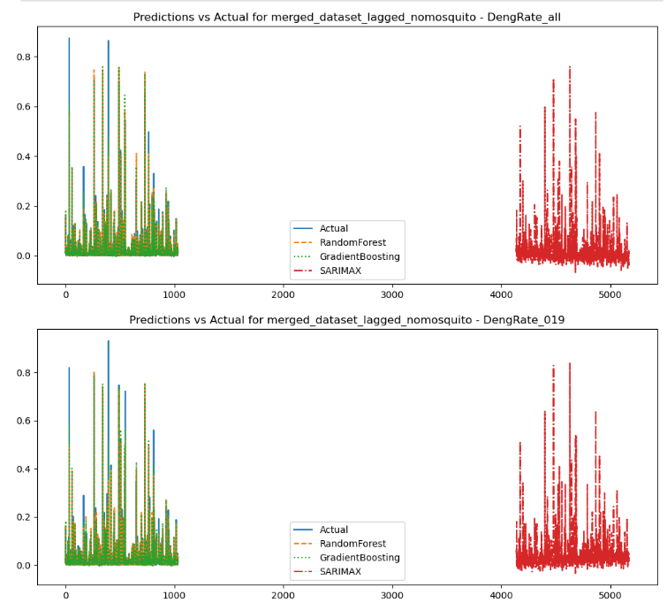
all baseline models.:
1. with added lag features, rollingavg+lag, ewma+lag
Results for Lagged_DengRate_all:
RandomForest: RMSE=0.0211, R²=0.9189, MAE=0.0043
GradientBoosting: RMSE=0.0190, R²=0.9340, MAE=0.0053
SARIMAX: RMSE=0.0291, R²=0.8455, MAE=0.0161

Results for Lagged_DengRate_019:
RandomForest: RMSE=0.0244, R²=0.9084, MAE=0.0044
GradientBoosting: RMSE=0.0196, R²=0.9410, MAE=0.0054
SARIMAX: RMSE=0.0493, R²=0.6260, MAE=0.0369
2. with added lag features only; NO rollingavg+lag, ewma+lag
Results for lagged_noewma_norollavg_DengRate_all:
RandomForest: RMSE=0.0212, R²=0.9175, MAE=0.0043
GradientBoosting: RMSE=0.0194, R²=0.9311, MAE=0.0054
SARIMAX: RMSE=0.0426, R²=0.6682, MAE=0.0318

Results for lagged_noewma_norollavg_DengRate_019:
RandomForest: RMSE=0.0244, R²=0.9084, MAE=0.0043
GradientBoosting: RMSE=0.0198, R²=0.9396, MAE=0.0055
SARIMAX: RMSE=0.0467, R²=0.6643, MAE=0.0345
3. with added lag features rollingavg+lag, ewma+lag and orignial features removed for which new versions were added
Results for lagged_nooriginal_DengRate_all:
RandomForest: RMSE=0.0236, R²=0.8980, MAE=0.0046
GradientBoosting: RMSE=0.0222, R²=0.9097, MAE=0.0056
SARIMAX: RMSE=0.0758, R²=-0.0501, MAE=0.0626

Results for lagged_nooriginal_DengRate_019:
RandomForest: RMSE=0.0254, R²=0.9009, MAE=0.0044
GradientBoosting: RMSE=0.0223, R²=0.9232, MAE=0.0056
SARIMAX: RMSE=0.0901, R²=-0.2494, MAE=0.0752

4. with added lag features only; NO rollingavg+lag, ewma+lag and orignial features removed for which new versions were added
Results for lagged_noewma_norollavg_nooriginal_DengRate_all:
RandomForest: RMSE=0.0236, R²=0.8985, MAE=0.0045
GradientBoosting: RMSE=0.0217, R²=0.9142, MAE=0.0055
SARIMAX: RMSE=0.1353, R²=-2.3429, MAE=0.1157

Results for lagged_noewma_norollavg_nooriginal_DengRate_019:
RandomForest: RMSE=0.0254, R²=0.9010, MAE=0.0044
GradientBoosting: RMSE=0.0216, R²=0.9283, MAE=0.0054
SARIMAX: RMSE=0.1523, R²=-2.5699, MAE=0.1307
5. original no lags
Results for Original_DengRate_all:
RandomForest: RMSE=0.0254, R²=0.8652, MAE=0.0053
GradientBoosting: RMSE=0.0203, R²=0.9134, MAE=0.0069
SARIMAX: RMSE=0.0375, R²=0.7049, MAE=0.0207

Results for Original_DengRate_019:
RandomForest: RMSE=0.0250, R²=0.8860, MAE=0.0052
GradientBoosting: RMSE=0.0185, R²=0.9373, MAE=0.0065
SARIMAX: RMSE=0.0378, R²=0.7395, MAE=0.0204

6. original no lags no google trends terms
Results for unlagged_nogt_DengRate_all:
RandomForest: RMSE=0.0224, R²=0.8947, MAE=0.0046
GradientBoosting: RMSE=0.0190, R²=0.9245, MAE=0.0061
SARIMAX: RMSE=0.0364, R²=0.7229, MAE=0.0196

Results for unlagged_nogt_DengRate_019:
RandomForest: RMSE=0.0249, R²=0.8872, MAE=0.0047
GradientBoosting: RMSE=0.0176, R²=0.9433, MAE=0.0059
SARIMAX: RMSE=0.0379, R²=0.7381, MAE=0.0202
7. original with only google terms lagged
Results for lagged_gtonly_DengRate_all:
RandomForest: RMSE=0.0309, R²=0.8726, MAE=0.0065
GradientBoosting: RMSE=0.0231, R²=0.9290, MAE=0.0071
SARIMAX: RMSE=0.0483, R²=0.6887, MAE=0.0258

Results for lagged_gtonly_DengRate_019:
RandomForest: RMSE=0.0263, R²=0.9186, MAE=0.0059
GradientBoosting: RMSE=0.0199, R²=0.9536, MAE=0.0069
SARIMAX: RMSE=0.1117, R²=-0.4658, MAE=0.0948

8. with added lag features, rollingavg+lag, ewma+lag, mosquito_interest dropped
Results for merged_dataset_lagged_nomosquito_DengRate_all:
RandomForest: RMSE=0.0212, R²=0.9178, MAE=0.0043
GradientBoosting: RMSE=0.0192, R²=0.9327, MAE=0.0053
SARIMAX: RMSE=0.0309, R²=0.8250, MAE=0.0184

Results for merged_dataset_lagged_nomosquito_DengRate_019:
RandomForest: RMSE=0.0245, R²=0.9080, MAE=0.0044
GradientBoosting: RMSE=0.0198, R²=0.9396, MAE=0.0056
SARIMAX: RMSE=0.0338, R²=0.8241, MAE=0.0204

lagged_noewma_norollavg_DengRate_all
Lagged_DengRate_all
etc.

